Thursday June 6
Considering Landscape Study Day II
Sainsbury Centre for Visual Arts Education Studio
Join us for day two of discussion inspired by Ackroyd & Harvey’s installations, this time focussing on Beuys’ Acorns. This study day and ‘in-conversation’ event follows a sequence of such occasions which accompany all Ackroyd and Harvey’s exhibitions. It will combine a range of ideas from the arts and sciences about trees, coinciding with and funded by our EU funded TAP project, Changing Landscapes programme. Join guest speakers for talks and discussions.
Programme:
10:30 Arrival, Registration and Coffee
Morning session to be chaired by Dr Veronica Sekules, Deputy Director and Head of Education and Research SCVA

10:40-10:45 Introduction
Dr Veronica Sekules, Deputy Director and Head of Education and Research SCVA

10:45-11:15 The role of trees in climate change
Asher Minns, Tyndall Centre for Climate Change

11:15-11:45 The destruction of the largest transitional forest in the tropics and the problem of energy generation in Central Brazil
Aristoteles Barcelos Neto, Lecturer in the Arts of the Americas, School of World Art, UEA

11.45-12:15 A tree-lined future for farming?
Martin Wolfe, Wakelyns Agroforestry and the Organic Research Centre
12:15-13:00 Discussion

13:00-14:00 Lunch (not provided)
Afternoon session to be chaired by Dr Simon Dell, Senior Lecturer, School of Art History and World Art Studies, UEA

14:00-14:30 Biodiversity and Oak Trees
Anne Edwards, John Innes Centre

14:30-15:00 Roots and meadows as cultural referents in the Anthropocene age: The landscape as archive and artists as archivists of the landscape- archive.
Edwina Fitzpatrick, Artist

15:00-15:30 Around Joseph Beuys
Dr Simon Dell, Senior Lecturer, School of Art History and World Art Studies, UEA

15:30-16:15 Beuys' Acorns: When is a tree a work of art, a forest a social movement?
Ackroyd & Harvey, Artists

16:15-17:00 In-conversation and plenary discussion
Led by Professor Andrew Watkinson, Director of Living with Environmental Change, with Heather Ackroyd and Dan Harvey.

17:00 Close

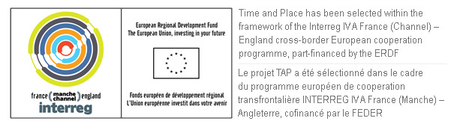
Please join us for a drink in Modern Life Café to celebrate Ackroyd & Harvey Beuys’ Acorns and Stranded and the Changing Landscapes programme of exhibitions and events.

